AWS SECRET MANAGER
Tasks on AWS Secrets Manager
- Create a Secret and Retrieve a Secret
  - Store database credentials (username and password) in AWS Secrets Manager.
  - Use both the console and AWS CLI
Step 1: Open Secrets Manager
Log in to AWS Console
Search for Secrets Manager
Click Secrets Manager
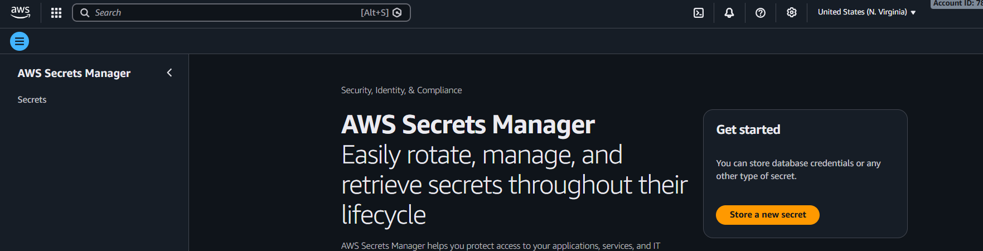
Step 2: Start Creating a Secret
Click Store a new secret
Select Other type of secret (generic key-value)
Enter Secret Values and Add key–value pairs
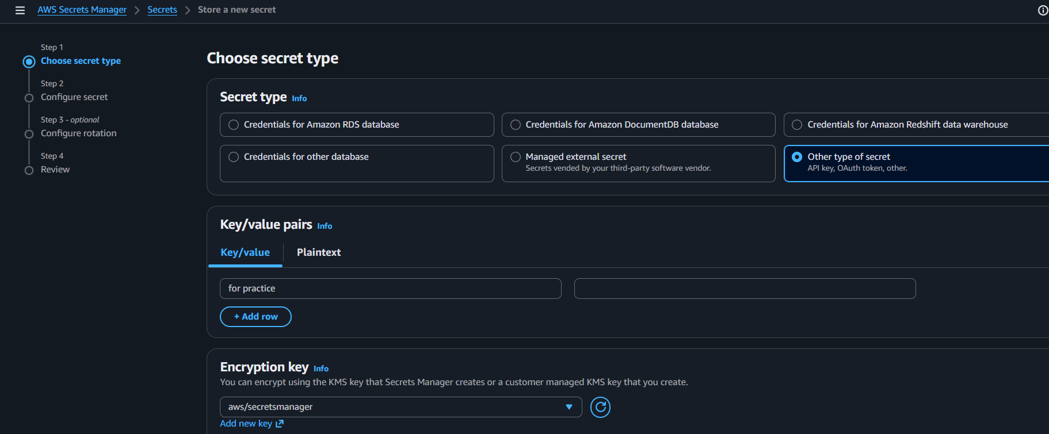
Step 3: Configure Secret Name
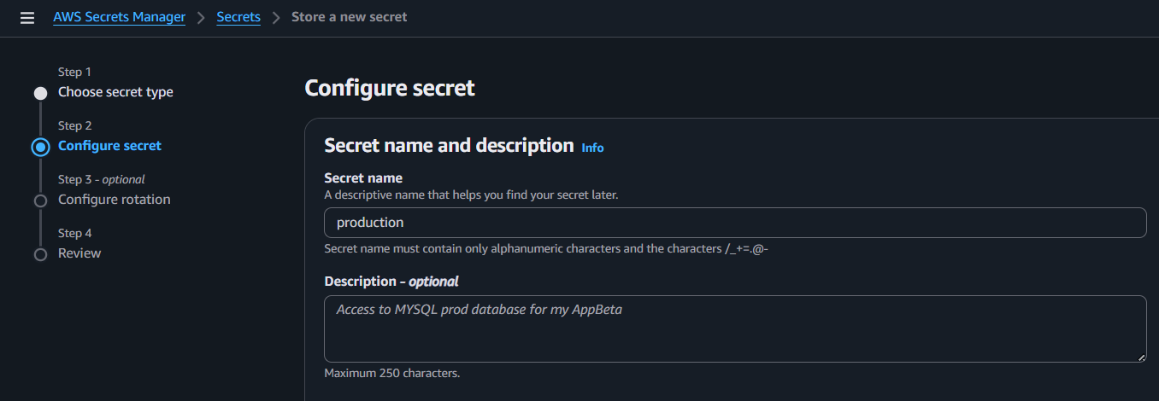
Review and create
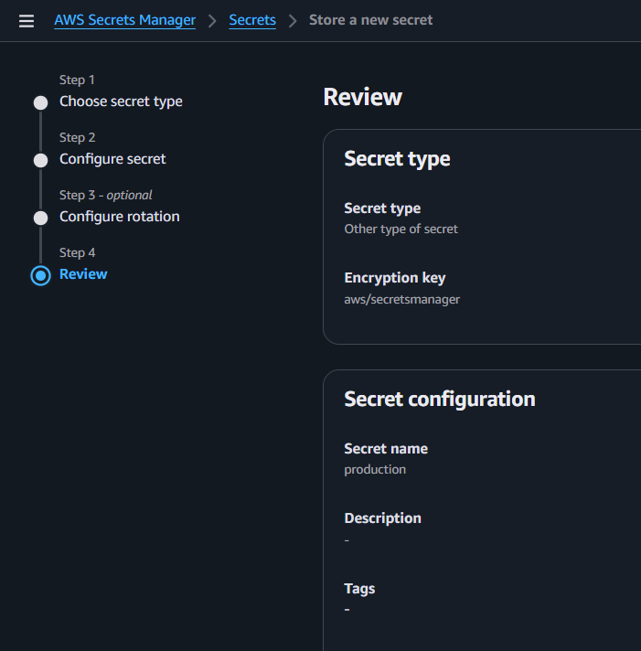

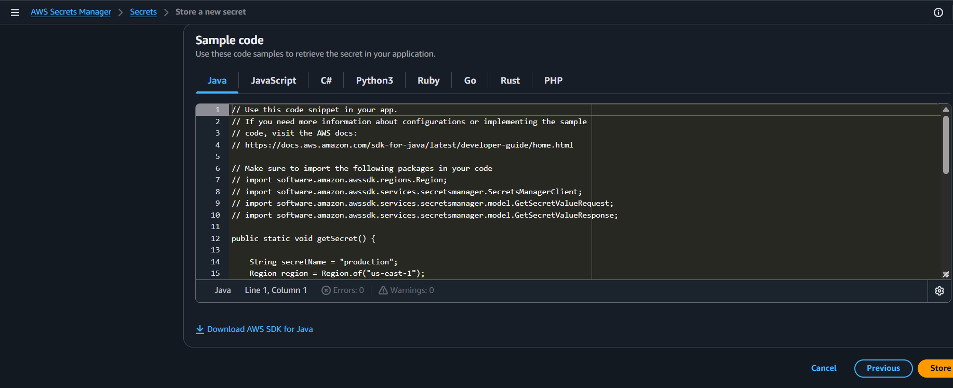
After creating click on secret name to verify
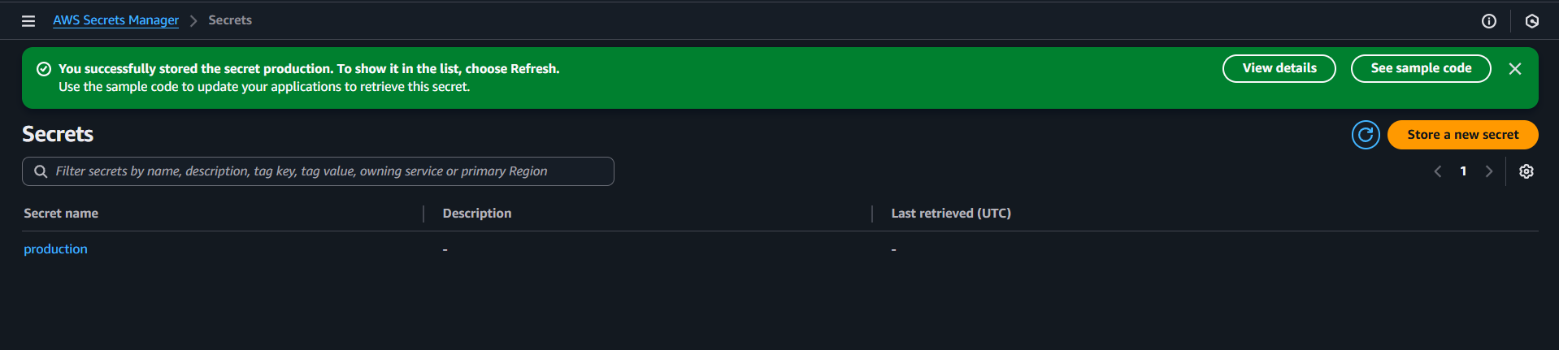
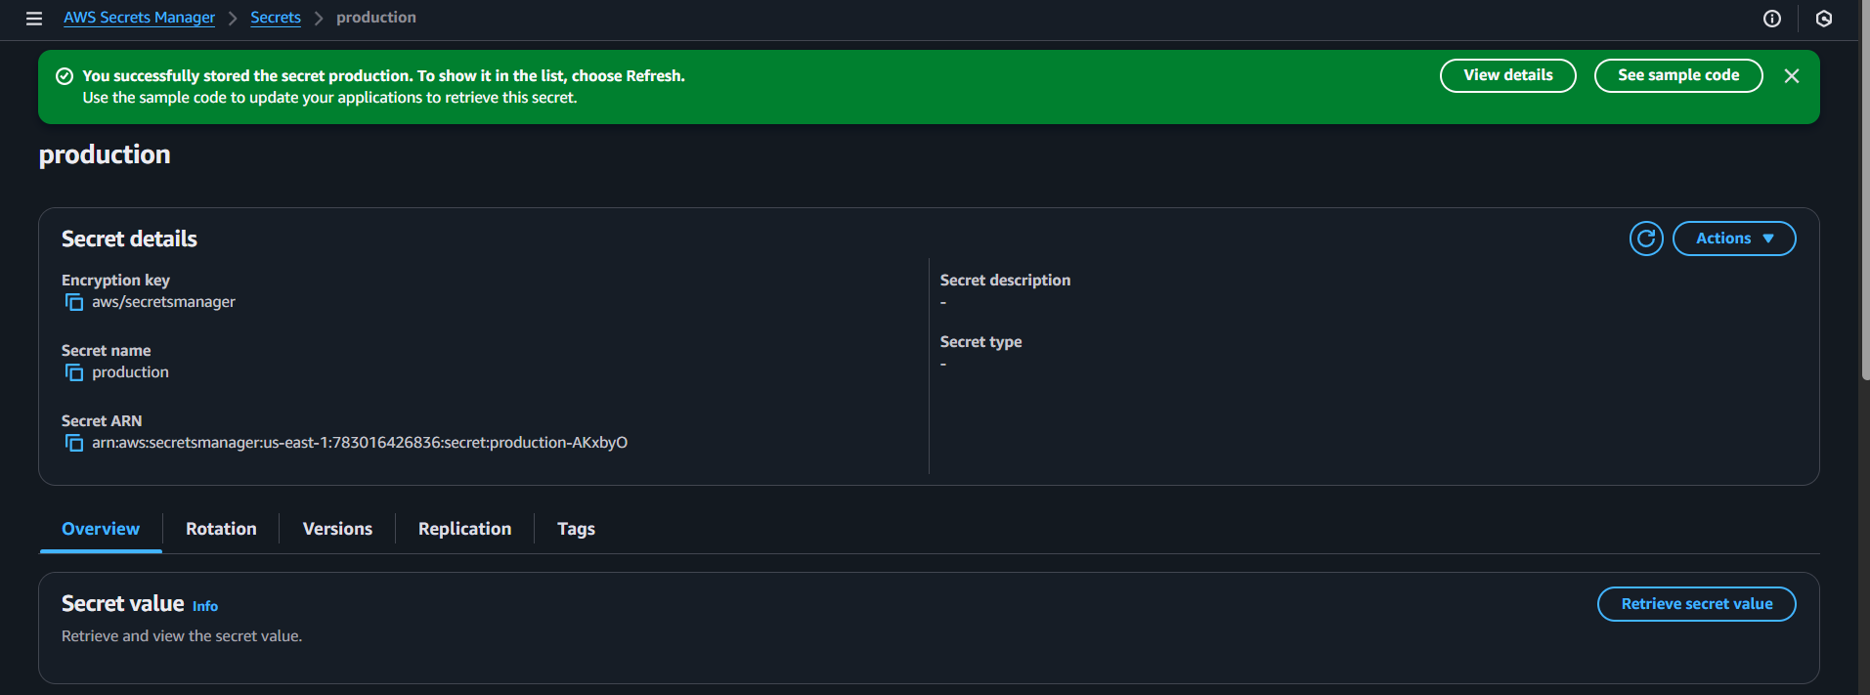
Validation part
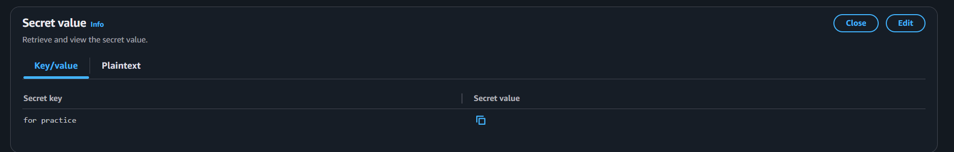

  - Using AWS CLI
Step 1: Create Secret Using CLI
Run this command
aws secretsmanager create-secret \
--name my-db-credentials-cli \
--description "Database credentials using CLI" \
--secret-string '{"username":"saiteja","password":"Devops@0509"}'
🔹 Prerequisite
Make sure AWS CLI is configured:
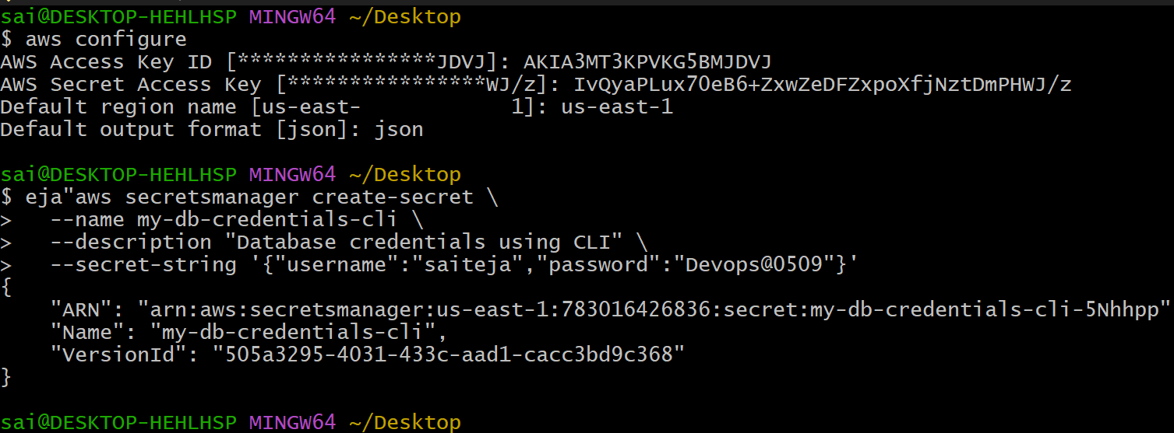
Step 2: Verify Secret Creation in GUI
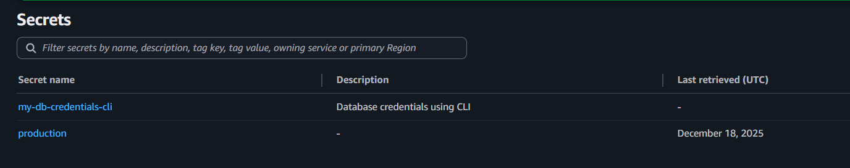
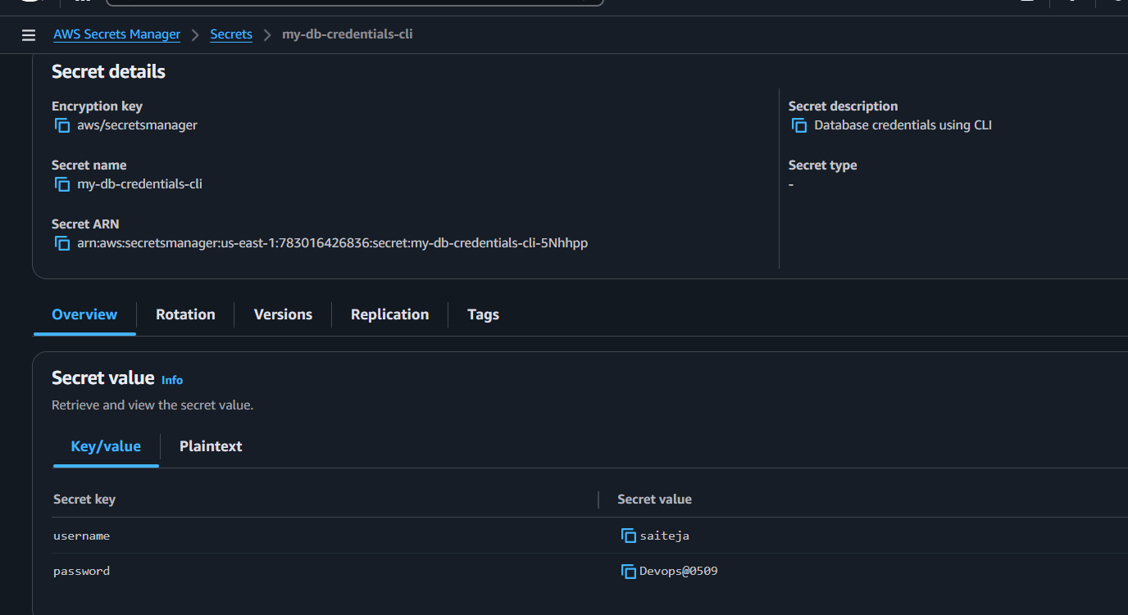
Step 3: Retrieve Secret Value Using CLI
Command:
aws secretsmanager get-secret-value \
--secret-id my-db-credentials-cli
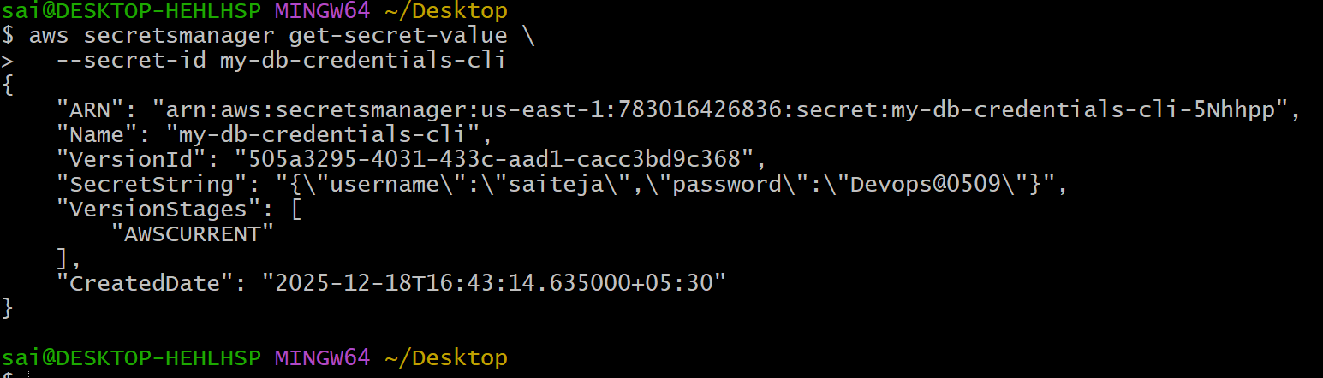
Conclusion:
In this task, we learned how to securely store sensitive database credentials using AWS Secrets Manager.
By creating secrets through both the AWS Management Console and the AWS CLI, we understood how Secrets Manager helps protect credentials using encryption and controlled access
Important Security Notes
- Secrets are encrypted automatically using AWS KMS
- You never hard-code passwords in code
- Access is controlled using IAM permissions

- Update a Secret
  - Modify an existing secret value and verify the updated version.
Step 1: Open Secrets Manager
Log in to AWS Console
Search for Secrets Manager
Click Secrets Manager
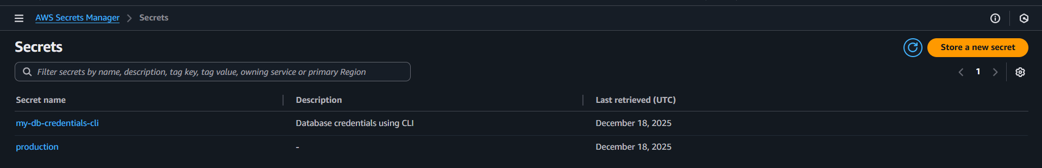
Step 2: Select the Existing Secret
From the secrets list, click your secret name
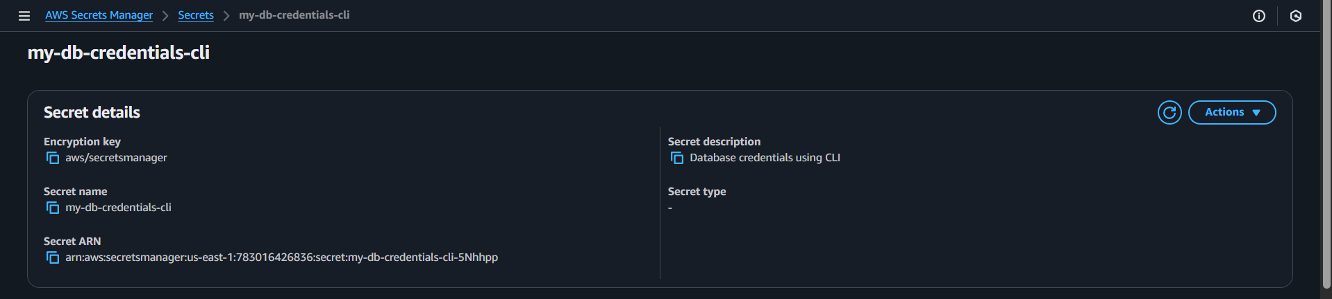
Step 3: Edit the Secret Value
Click Retrieve secret value
Click Edit
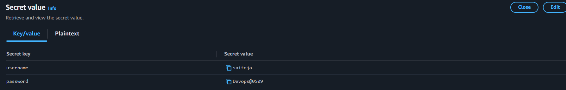
Add the details and continue
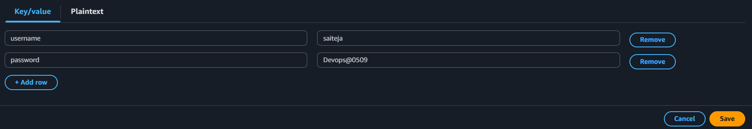
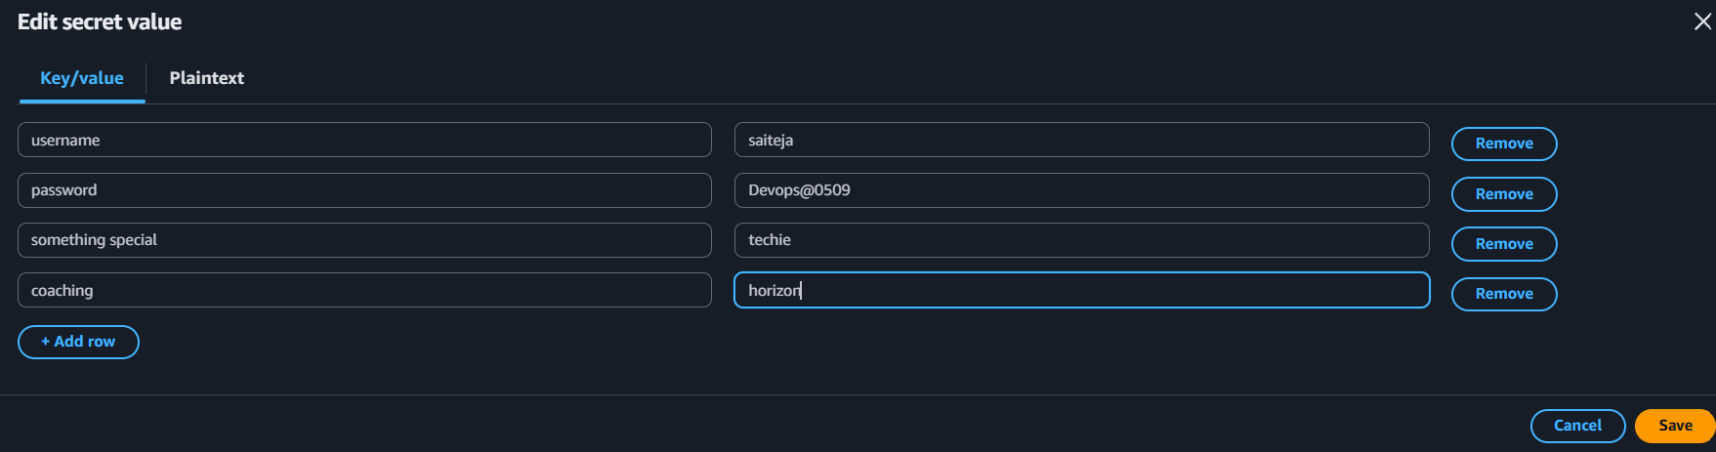
New values updated
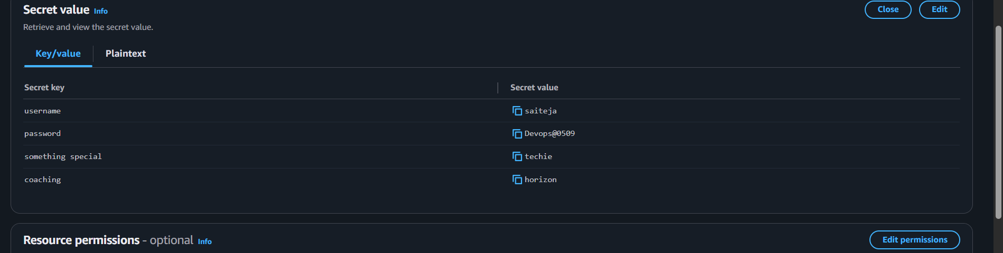
Verify New Version Created
Scroll to Versions
You will see:
AWSCURRENT → latest version
AWSPREVIOUS → old version
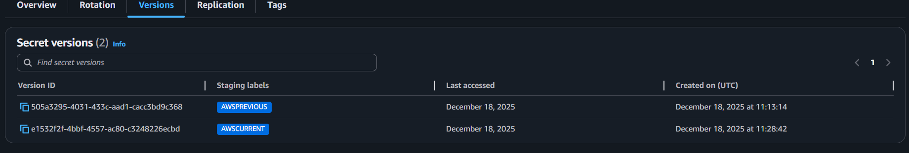
Update a Secret Using AWS CLI
Prerequisite
AWS CLI configured:
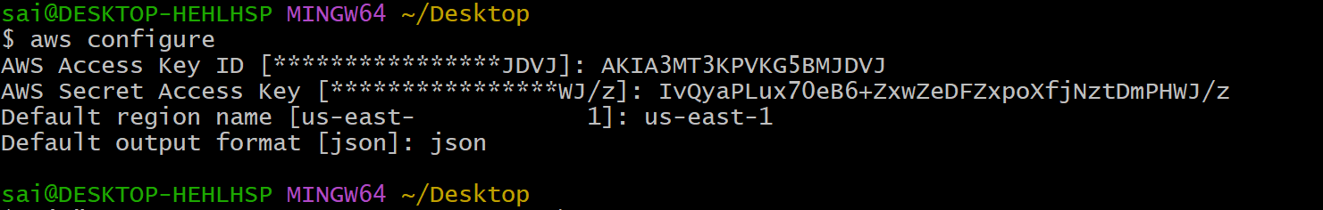

Step 1: Update Secret Value
aws secretsmanager update-secret \
--secret-id my-db-credentials-cli \
--secret-string '{"username":"admin","password":"mysecurepassword456"}'
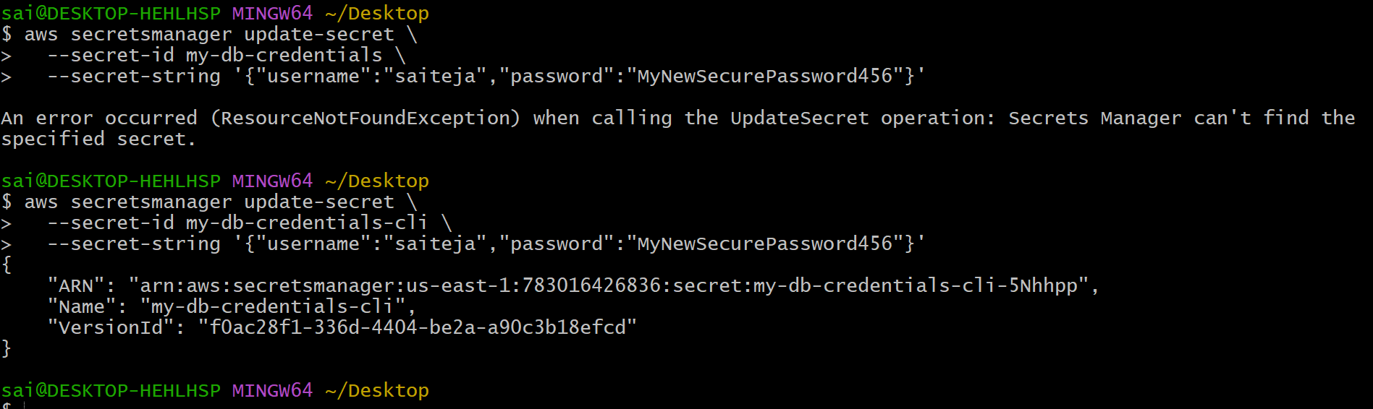
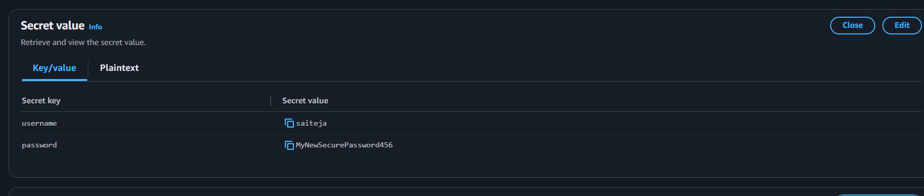
Step 2: Verify Updated Secret in CLI
aws secretsmanager get-secret-value \
--secret-id my-db-credentials-cli \
--query SecretString \
--output text
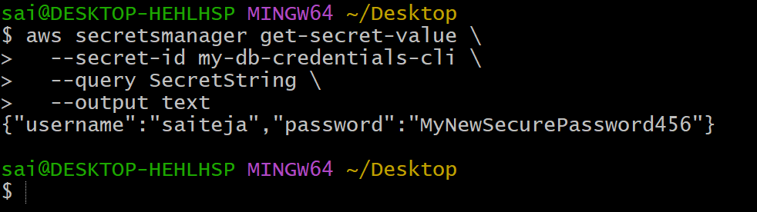

Important Notes
- Updating a secret does not delete old values
- AWS automatically versions secrets
- Applications using the secret always read AWSCURRENT
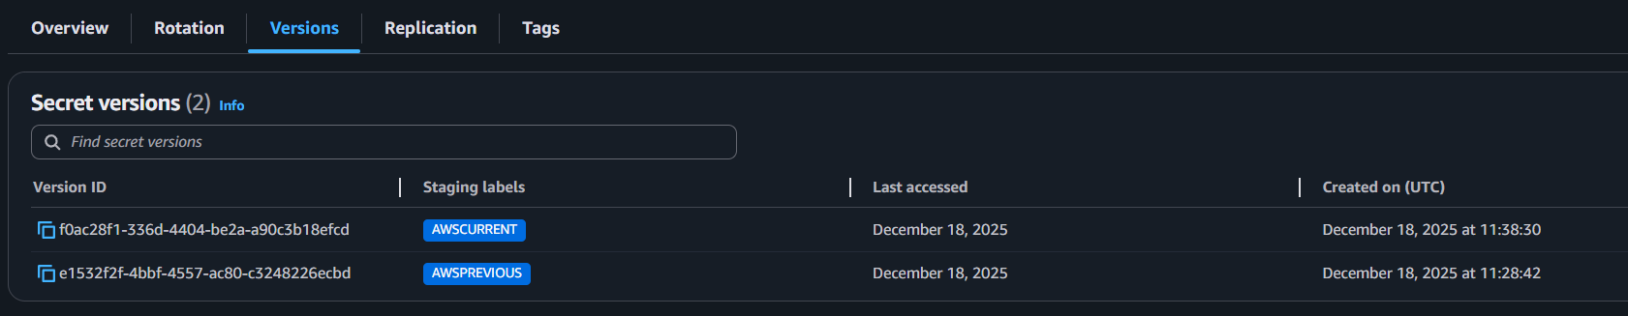
Conclusion:
Updating a secret in AWS Secrets Manager allows secure modification of sensitive data while automatically maintaining version history. This ensures applications always access the latest secret without downtime or manual credential changes.

